Download the Setup from https://www.virtualbox.org/wiki/Downloads

Go to System Preferences > Security & Privacy. Click the ‘Allow’ button at the bottom. Re-run the installer. More detailed instructions are below.

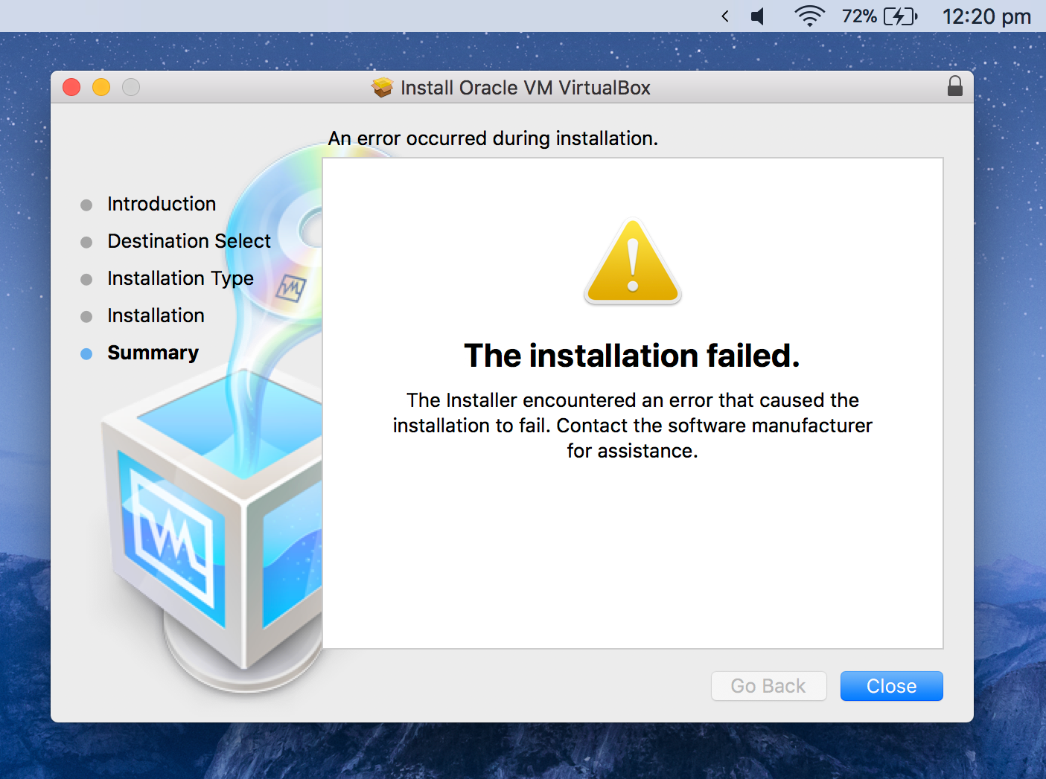

VirtualBox has an error when installing.

* Run the VirtualBox installer just like any other installer.
* You might see a prompt from macOS about not allowing unsecure system extensions. You can click ‘Next’ for now.
* After reaching the end, installation will fail with the message above.
* Navigate to System Preferences > Security & Privacy. At the bottom of the window, you should see a message saying “System software from developer, ‘Oracle, America, Inc.‘ was blocked from loading.”

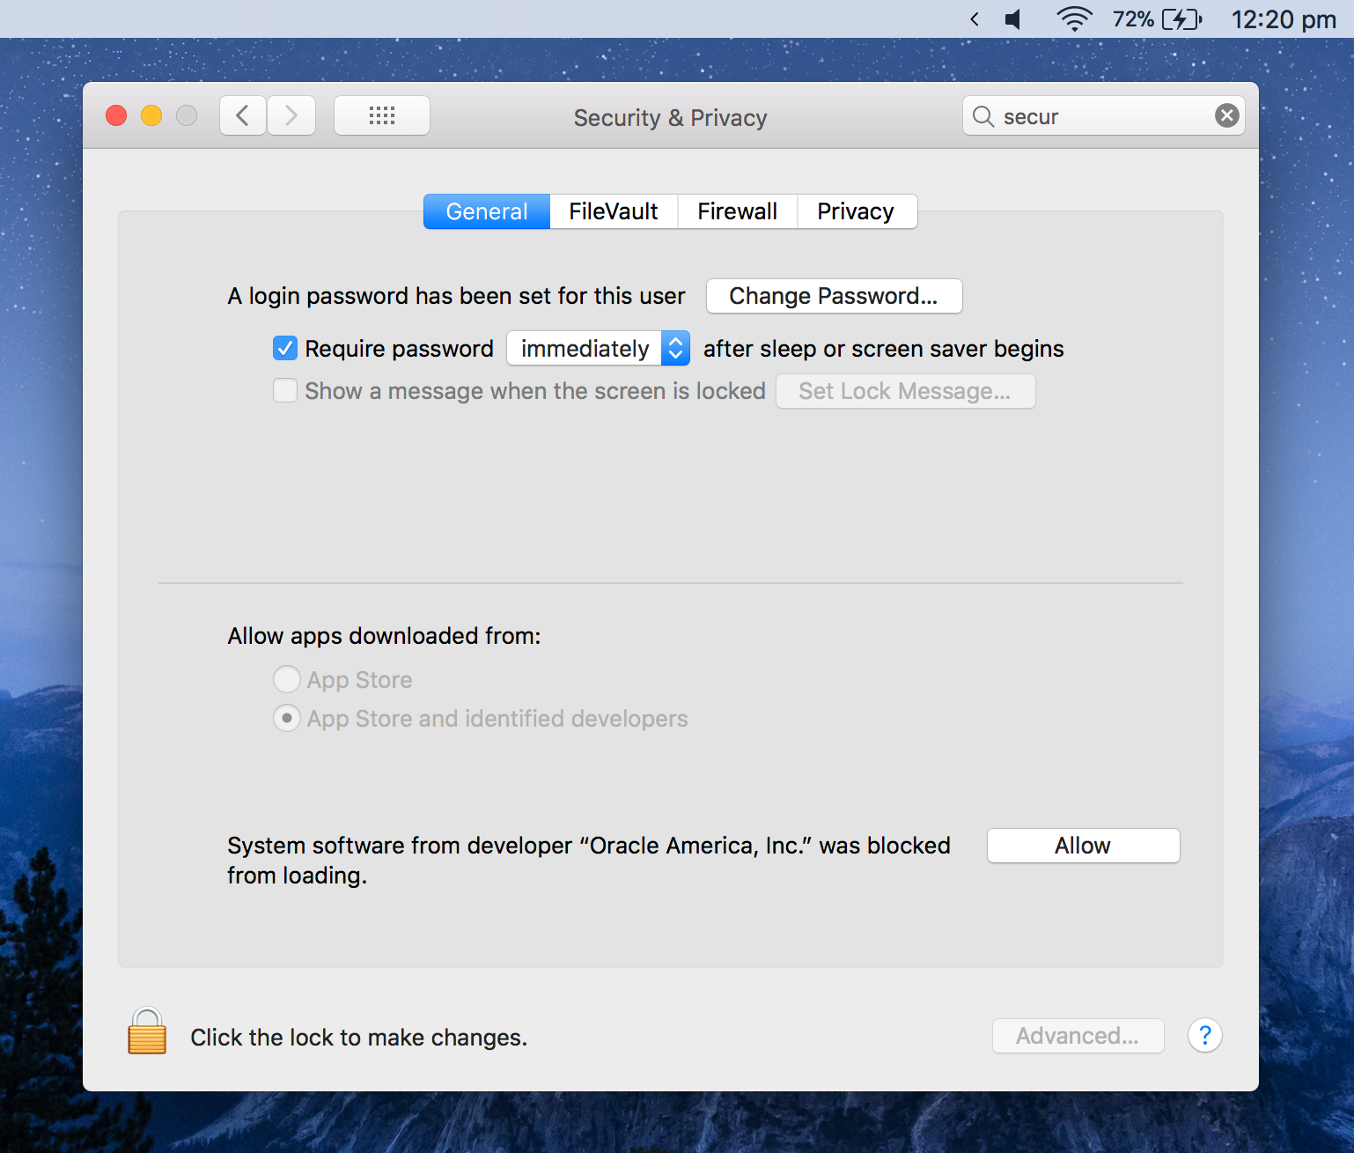

* Click the lock in the bottom left corner, enter your password
* Click ‘Allow’ next to the ”blocked from loading” message.
* Re-run the VirtualBox installer. It should succeed.

